https://howtodoinjava.com/spring-boot/spring-boot-and-angular-application-example/

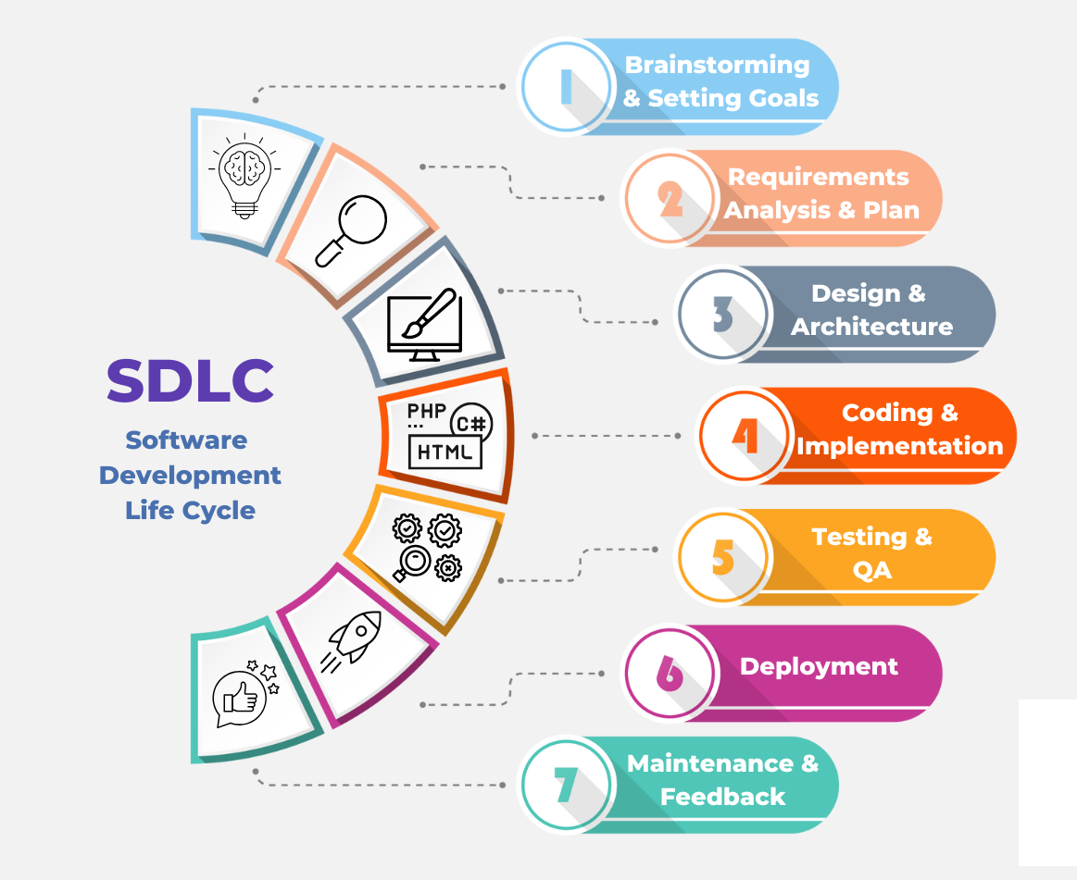

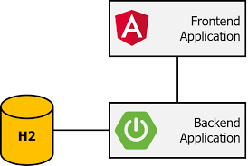

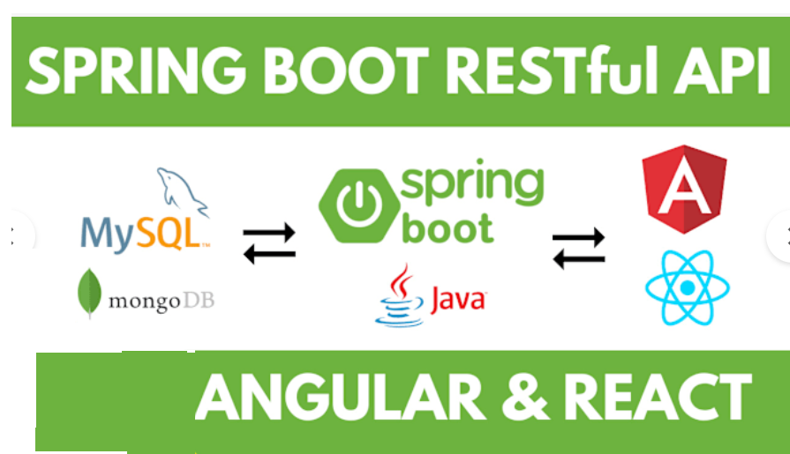

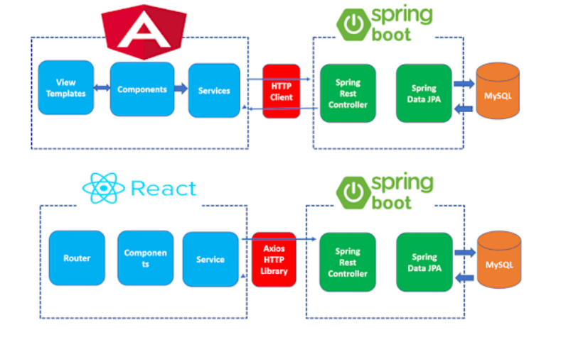

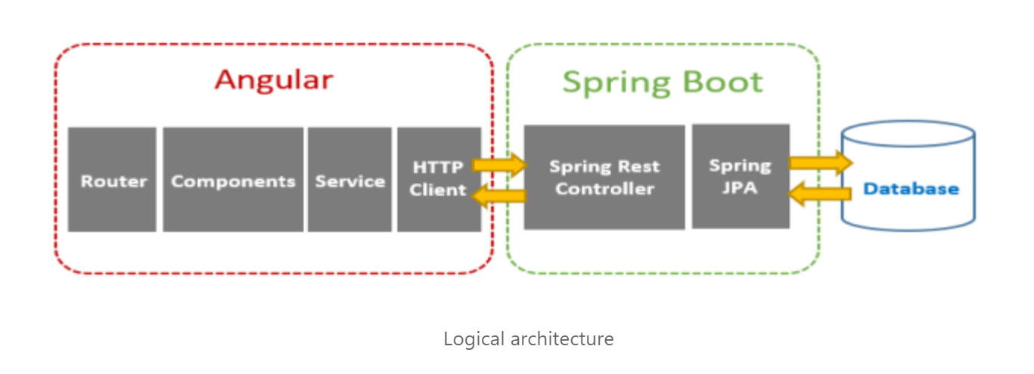

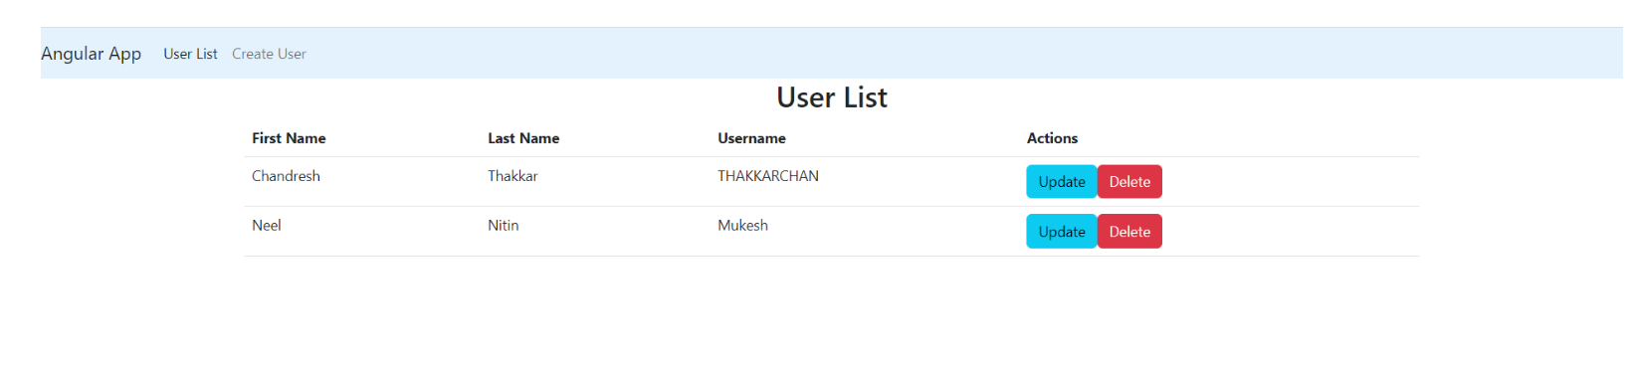

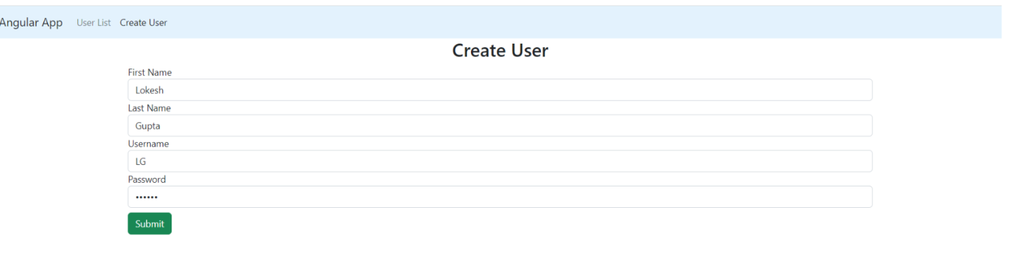

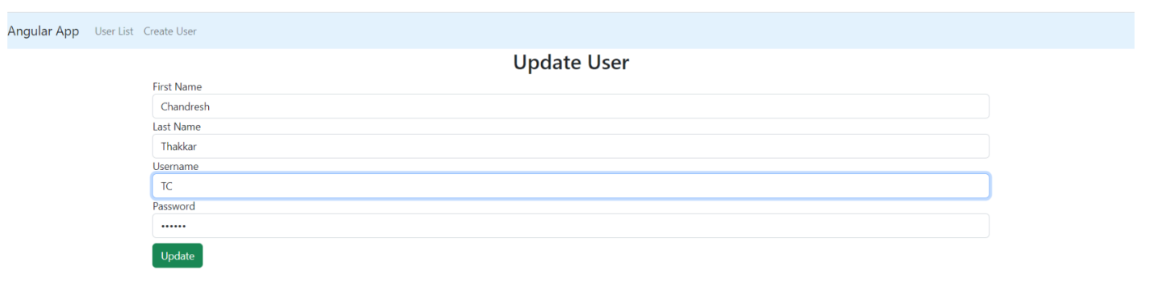

Spring boot is the latest and most famous backend Java Framework and Angular is the most recommended frontend UI Framework by industry experts.

we will create a very simple User Management application. The application will have a very simple UI that will list all the available users in the system and options to add a user and update /or delete an existing user using the links or buttons.

We will develop a Spring Boot application to manage user information like “firstname”, “lastname”, “username” and “password” of a user, for demo purposes.

GET: localhost:8080/users // List all avialble users

POST: localhost:8080/users // Create a new user

GET: localhost:8080/users/{id} // Get a user by id

PUT: localhost:8080/users/{id} // Update a user information

DELETE: localhost:8080/users/{id} // Delete a User

